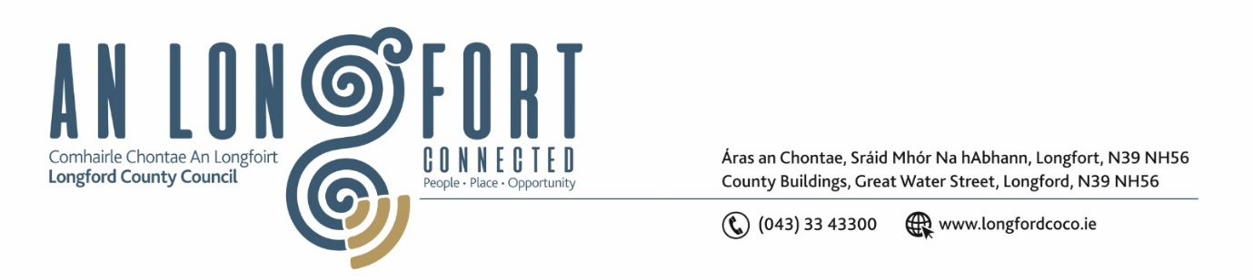

***LONGFORD MUNICIPAL DISTRICT***

***Please note meeting will be held in the Council Chamber, Aras an Chontae and via Microsoft Teams***

**19 May 2022.**

**To: Each Member of Longford Municipal District.**

**Dear Member,**

You are requested to attend the Meeting of Longford Municipal District to be held in **the Council Chamber, Aras An Chontae** and **via Microsoft Teams** on **Wednesday 25 May 2022 at 3.30pm** to transact business, as set out on the Agenda hereunder.

**Yours sincerely**,

Ann Marie Mc Keon

_______________

**Ann Marie Mc Keon**

**Meetings Administrator.**

**AGENDA**

Prayer before meeting.

**1.** Confirmation of Minutes of Longford Municipal District Meeting held on Wednesday 26 April 2022 – copy enclosed.

**2.** Matters arising from Minutes.

**3.** Declaration of Interest by Members.

**4.** Management Report - enclosed.

**5**. Proposed Projects/Expression of interests.

**6.** Polling Scheme Review.

**7.** Update on Major Well’s Road Scheme.

**8.** Community Grant Support Scheme 2022 – enclosed.

**9. Notices of Motions, submitted by Councillors, as listed hereunder –**

**Councillor Martin Monaghan**

That Longford Municipal District look to implement a bike sharing scheme in key locations in our county town.

**Joint Notice by Councillors Uruemu Adejinmi/Seamus Butler/Martin Monaghan - enclosed**

“We call on Longford County Council to inaugurate a process to explore twinning possibilities between Mullheim Am Main in Germany and Longford Town”.

This is in response to an invitation to connect at Municipal level and explore opportunities mutually beneficial to both towns. The attached document refers.

**10.** Correspondence dated 12 May 2022 – Ballymahon Twinning Group – enclosed.